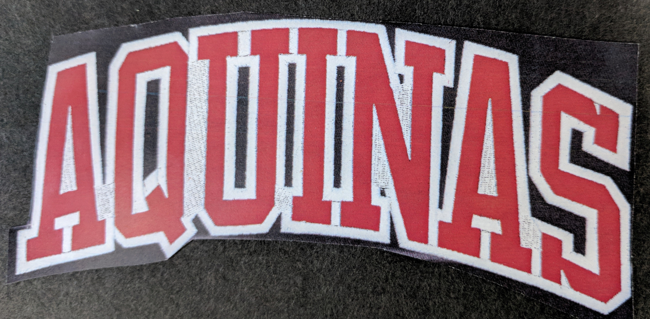

STA
Grad Wear 2019
Order Form

 | SMALL | MEDIUM | LARGE | XLARGE | COST | TOTAL
Black Hoodie |  |  |  |  | $54
Dark Heather Hoodie |  |  |  |  | $54
Black Crew Neck |  |  |  |  | $50
Dark Heather Crew Neck |  |  |  |  | $50
Black sweatpants |  |  |  |  | $34

Grand total: _______________

Tops have the above logo stitched across the front and a small 19 on the sleeve. Pants have a logo on the upper thigh.

Sample sizes are available to try on in the library. Please submit order form and payment (cheques made out to STA) to Ms. Mattia in the library.

Student Name: Phone:

